# ASSIGNMENT NO. 6

**Aim/objective:**

To develop any distributed application using Messaging System in Publisher-Subscriber paradigm.

**Tools / Environment:**

Java Programming Environment, JDK 8, Eclipse IDE, Apache ActiveMQ 4.1.1, JMS

OUTPUT

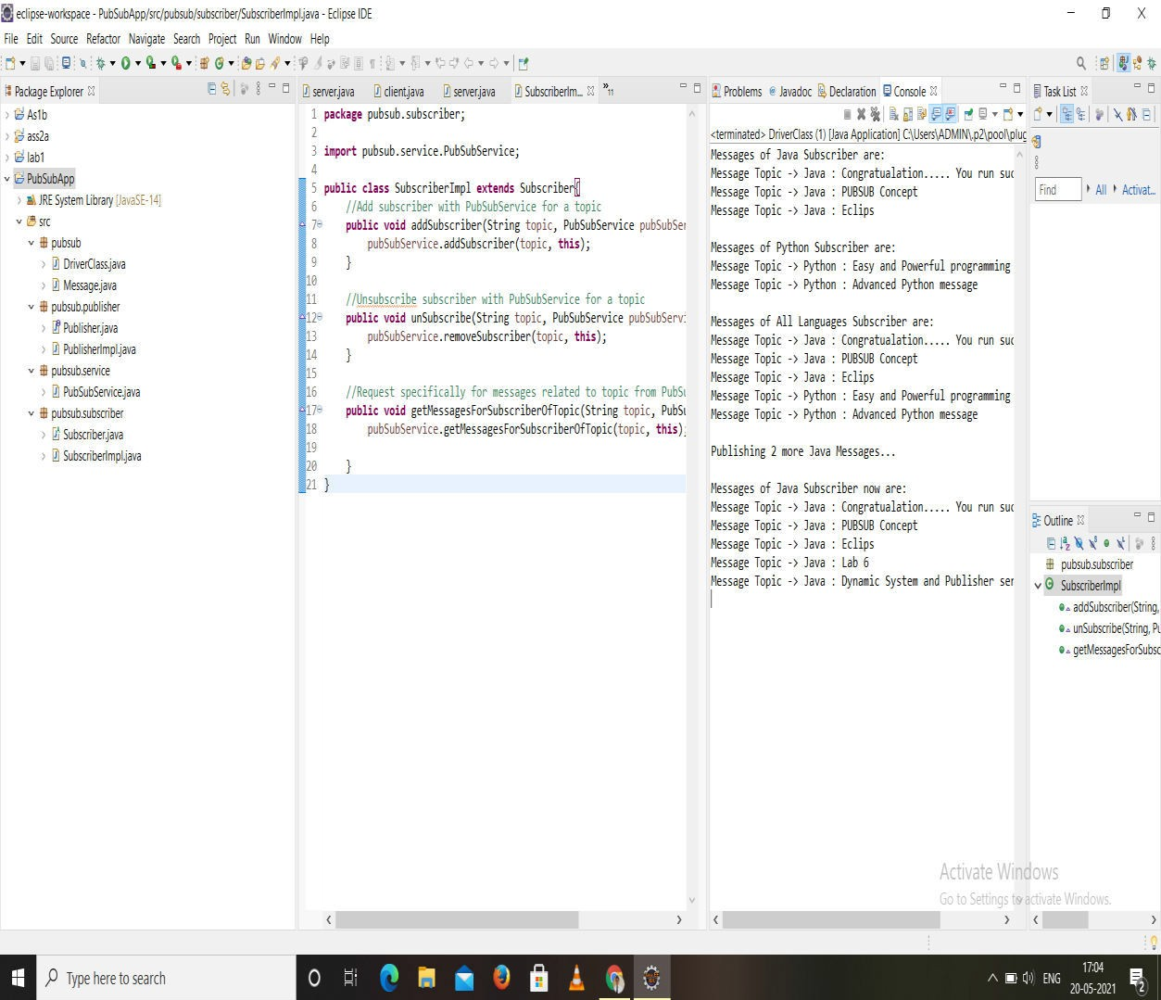

//Driver

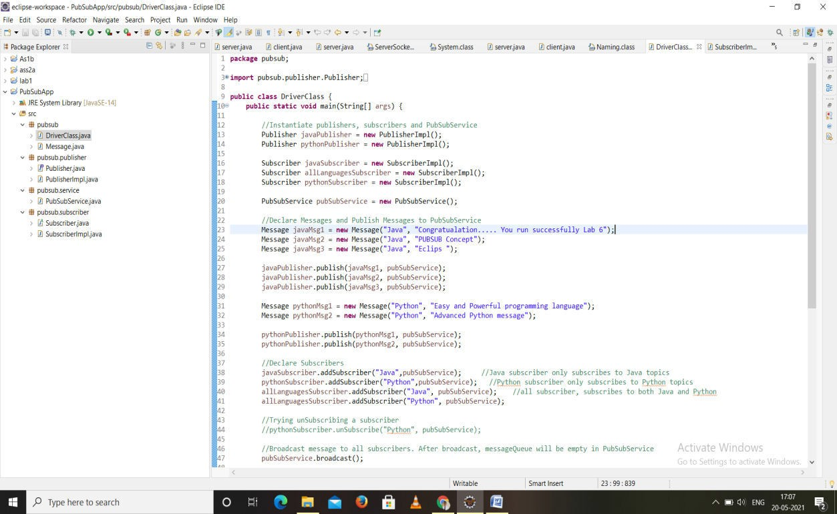

package pubsub;

import pubsub.publisher.Publisher; import pubsub.publisher.PublisherImpl; import pubsub.service.PubSubService; import pubsub.subscriber.Subscriber; import pubsub.subscriber.SubscriberImpl;

public class DriverClass {

public static void main(String[] args) {

//Instantiate publishers, subscribers and PubSubService Publisher javaPublisher = new PublisherImpl(); Publisher pythonPublisher = new PublisherImpl();

Subscriber javaSubscriber = new SubscriberImpl(); Subscriber allLanguagesSubscriber = new SubscriberImpl(); Subscriber pythonSubscriber = new SubscriberImpl();

PubSubService pubSubService = new PubSubService();

//Declare Messages and Publish Messages to PubSubService

Lab 6");

language");

Message javaMsg1 = new Message("Java", "Congratualation..... You run successfully

Message javaMsg2 = new Message("Java", "PUBSUB Concept"); Message javaMsg3 = new Message("Java", "Eclips ");

javaPublisher.publish(javaMsg1, pubSubService); javaPublisher.publish(javaMsg2, pubSubService); javaPublisher.publish(javaMsg3, pubSubService);

Message pythonMsg1 = new Message("Python", "Easy and Powerful programming Message pythonMsg2 = new Message("Python", "Advanced Python message");

pythonPublisher.publish(pythonMsg1, pubSubService); pythonPublisher.publish(pythonMsg2, pubSubService);

//Declare Subscribers

javaSubscriber.addSubscriber("Java",pubSubService); //Java subscriber only subscribes to Java topics

pythonSubscriber.addSubscriber("Python",pubSubService); //Python subscriber only subscribes to Python topics

allLanguagesSubscriber.addSubscriber("Java", pubSubService); //all subscriber, subscribes to both Java and Python

allLanguagesSubscriber.addSubscriber("Python", pubSubService);

//Trying unSubscribing a subscriber

//pythonSubscriber.unSubscribe("Python", pubSubService);

//Broadcast message to all subscribers. After broadcast, messageQueue will be empty in PubSubService

pubSubService.broadcast();

//Print messages of each subscriber to see which messages they got System.out.println("Messages of Java Subscriber are: "); javaSubscriber.printMessages();

System.out.println("\nMessages of Python Subscriber are: "); pythonSubscriber.printMessages();

System.out.println("\nMessages of All Languages Subscriber are: "); allLanguagesSubscriber.printMessages();

server

services");

//After broadcast the messagesQueue will be empty, so publishing new messages to

System.out.println("\nPublishing 2 more Java Messages..."); Message javaMsg4 = new Message("Java", "Lab 6");

Message javaMsg5 = new Message("Java", "Dynamic System and Publisher

javaPublisher.publish(javaMsg4, pubSubService); javaPublisher.publish(javaMsg5, pubSubService);

javaSubscriber.getMessagesForSubscriberOfTopic("Java", pubSubService); System.out.println("\nMessages of Java Subscriber now are: "); javaSubscriber.printMessages();

}

}

//class

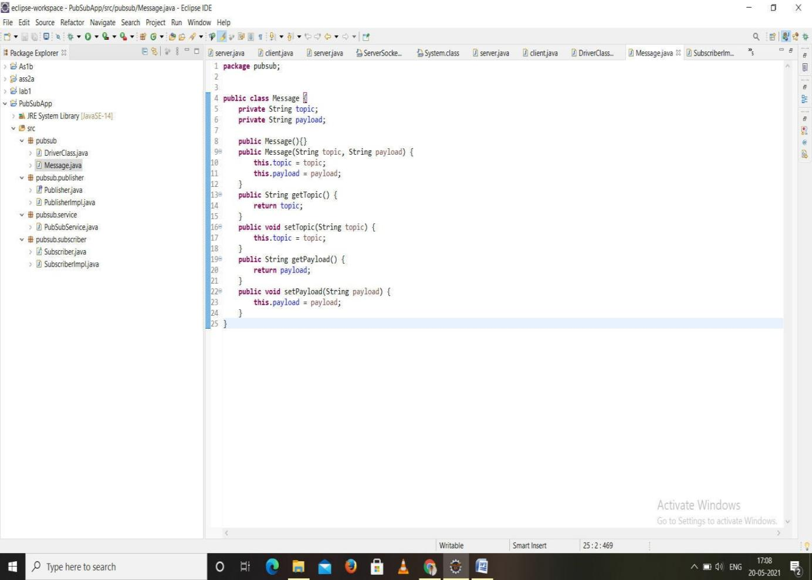

//Publisher

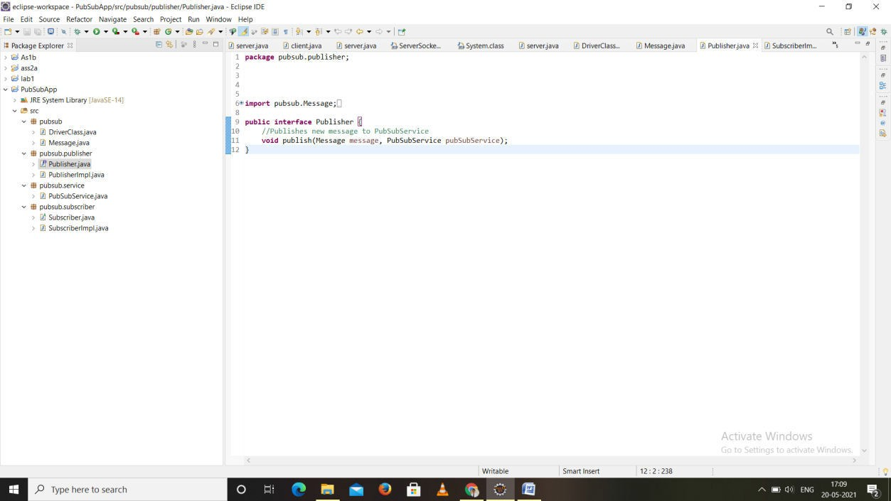

//Publisher impl

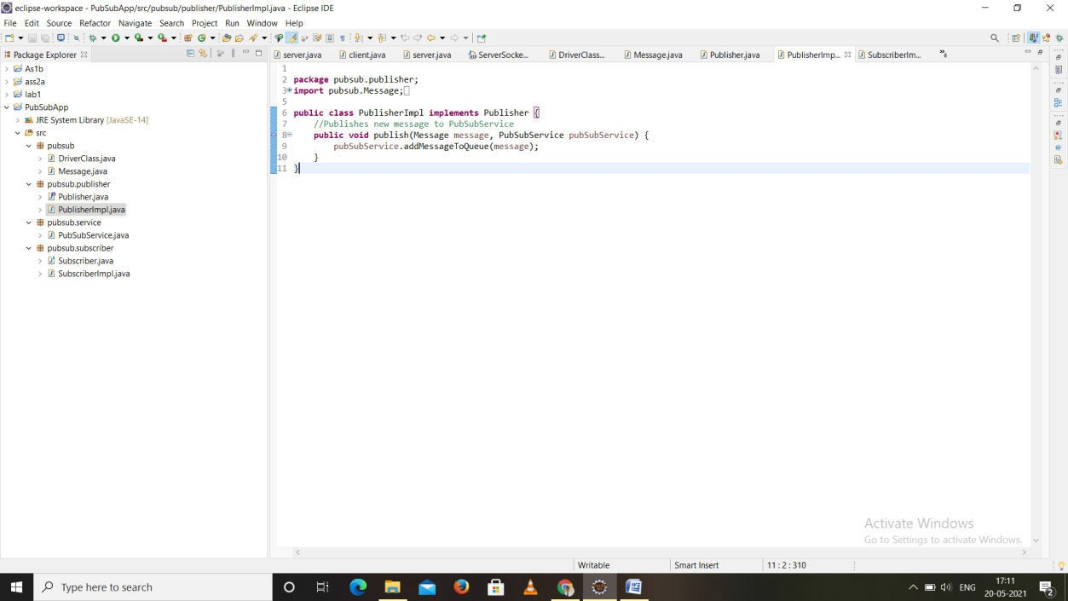

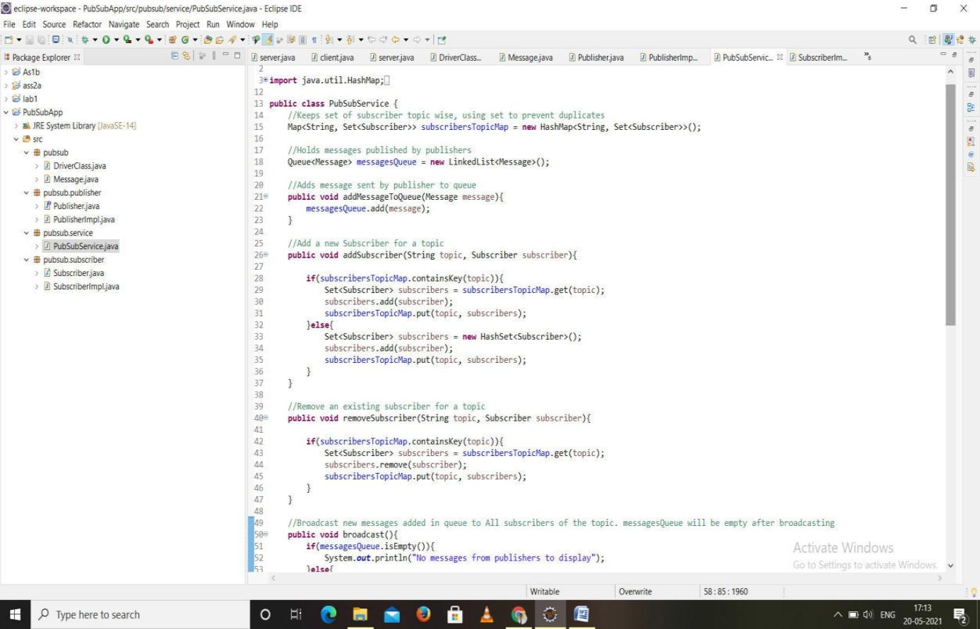

//Suciber

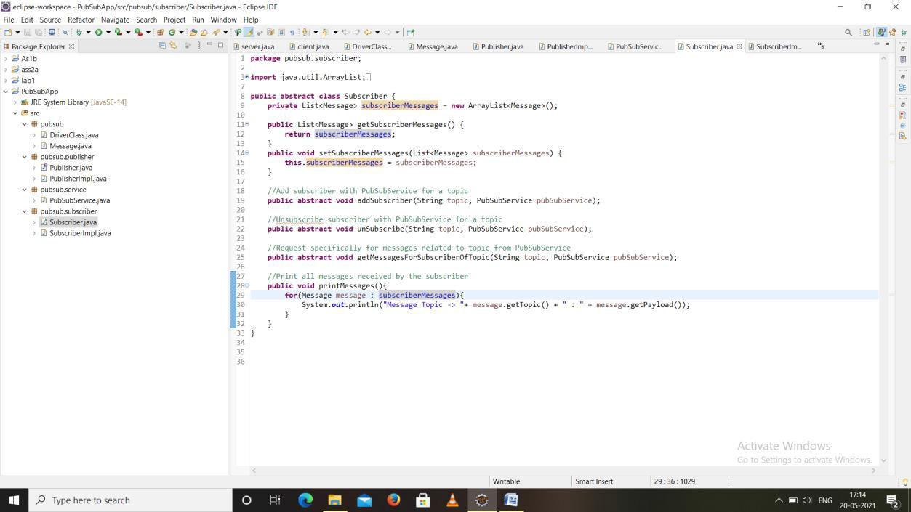

# Related Theory:

Large distributed systems are often overwhelmed with complications caused by heterogeneity and interoperability. Heterogeneity issues may arise due to the use of different programming languages, hardware platforms, operating systems, and data representations. Interoperability denotes the ability of heterogeneous systems to communicate meaningfully and exchange data or services. With the introduction of middleware, heterogeneity can be alleviated and interoperability can be achieved.

Middleware is a layer of software between the distributed application and the operating system and consists of a set of standard interfaces that help the application use networked resources and services.

**Enterprise Messaging System:**

EMS, or the messaging system, defines system standards for organizations so they can define their enterprise application messaging process with a semantically precise messaging structure. EMS encourages you to define a loosely coupled application architecture in order to define an industry-accepted message structure; this is to ensure that published messages would be persistently consumed by subscribers. Common formats, such as XML or JSON, are used to do this. EMS recommends these messaging protocols: DDS, MSMQ, AMQP, or SOAP web services. Systems designed with EMS are termed **Message-Oriented Middleware (MOM)**. An asynchronous communication is used while messaging in EMS

.

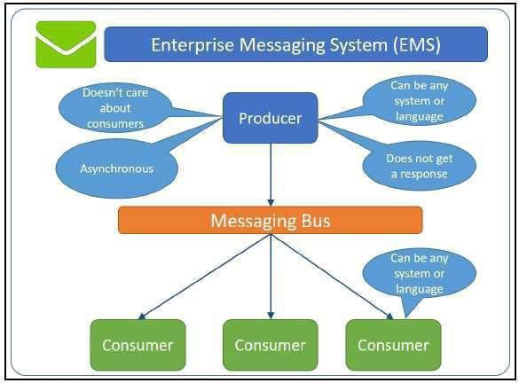

**Java's implementation of an EMS in the Application Programming Interface (API) format is known as JMS.**

JMS allows distributed Java applications to communicate with applications developed in any other technology that understands messaging through asynchronous messages. JMS applications contain a provider, clients, messages, and administrated objects.

JMS providing a standard, portable way for Java programs to send/receive messages through a MOM product. Any application written in JMS can be executed on any MOM

that implements the JMS API standards. The JMS API is specified as a set of interfaces as part of the Java API. Hence, all the products that intend to provide JMS behavior will have to deliver the provider to implement JMS-defined interfaces. With programming patterns that allow a program to interface, you should be able to construct a Java application in line with the JMS standards by defining the messaging programs with client applications to exchange information through JMS messaging

**Conclusion:**

This assignment includes study of Publish-Subscribe model of Communication which is implemented using JMS and Apache ActiveMQ. The topic based filtering requires the messages to be broadcasted into logical channels, the subscribers only receives messages from logic channels they are subscribed.